Problem 3 - Enigmanation
Edward Nigma (the Riddler) is one of the most formidable adversaries of the almighty Dark Knight. That is because of the superior intelligence of the Riddler. He has just put Batman into the enigmanation, a state where the Batman’s imagination is controlled by The Riddler.
The only way for the Dark Knight to escape the enigmanation is to solve the Riddler’s riddle. This time the riddle is to find the exit code. The exit code is the result from a complex mathematical expression.
The code is actually a mathematical expression. Each mathematical expression can contain SUM, SUBTRACT, MODULE and/or MULTIPLY operations. The expression is solved like a calculator would do (example follows) and can contain brackets. Everything inside an opening and closing bracket is solved first. An expression can contain multiple brackets, but cannot contain nested brackets (i.e. expression containing (… (…)…) is invalid, but expression containing (…)… (…) is valid).
Example:
Given the expression:
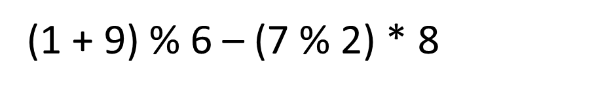
It is solved as follows:
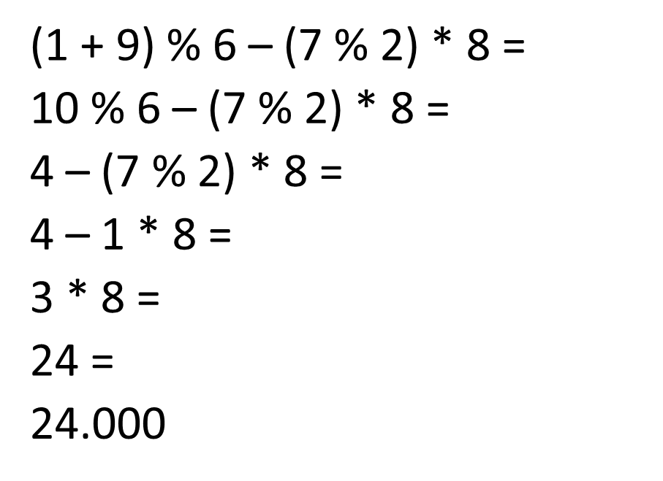
Batman is pretty smart, but he is busy fighting with the monsters in the enigmanation. He needs your help to escape from the enigmanation and capture the Riddler.

Input
The input data consists of single line on the console
The line represents the code to solve. The line will always end with the symbol ‘=‘. The ‘=’ at the end marks the end of the code.
The input data will always be valid and in the format described. There is no need to check it explicitly.

Output
The output data should be printed at the console on a single line – the result from the calculated code.
The result should be rounded to the 3 digit after the decimal point

Constraints
- The code will contain no more than 2500 characters
- The numbers in an code will always be in the range [1…9]
- The operators in an code will always be among + (SUM), – (SUBTRACT), % (MODULE)
or * (MULTIPLY)
- The result will always be in the range [-100000.000, 100000.000]
- Allowed work time for your program: 0.1 seconds.
- Allowed memory: 4 MB.

Examples
Input | (1+9)%6–(7%2)*8=
Output | 24.000
Input | (6%5)*9+(8*3%7)*7%2*(5%3+4*1)=
Output | 0.000
Input | 1*2*3*4*5*6*7*8*9%1-9=
Output | -9.000

